Uriel Escobar

uesco001

EE114 Coding HW 3

1. *Plot the histogram of continuous features*

This part is to show how the population is distributed among certain categories

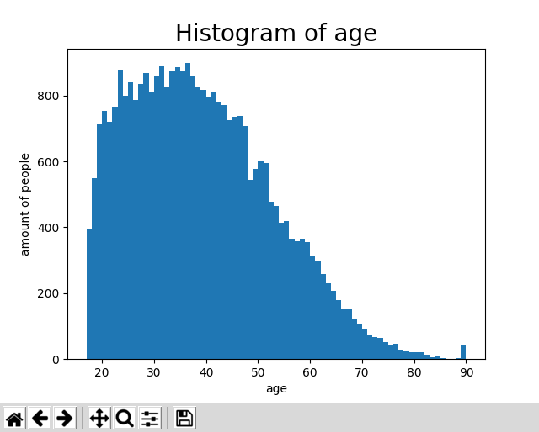

Figure 1 Histogram of age

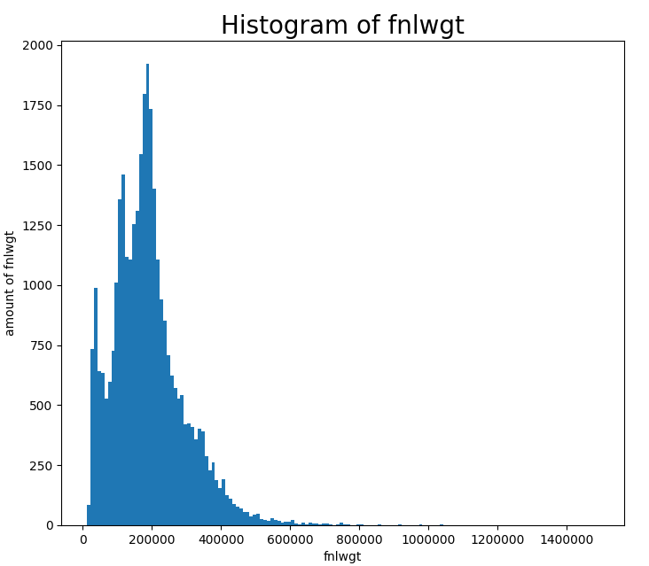

Figure 2 Histogram of fnlwgt

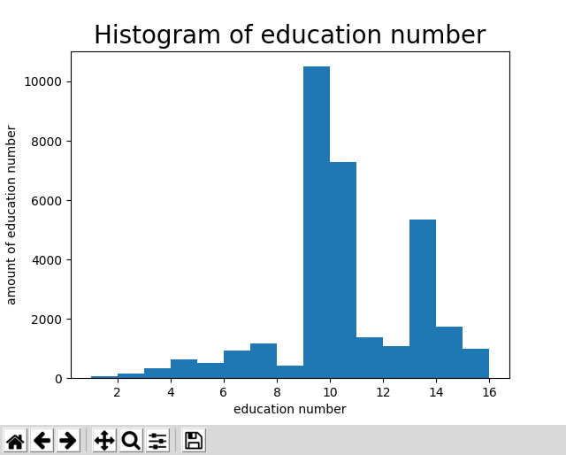

Figure 3 Hist of educatin number

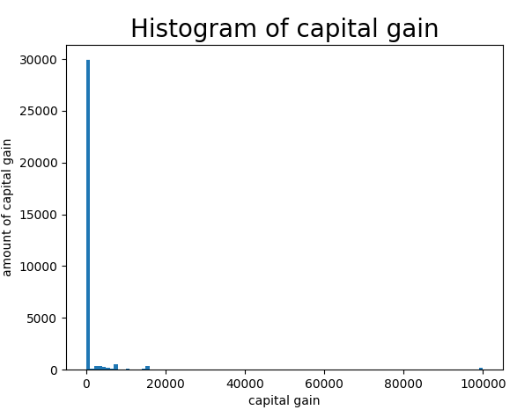

Figure 4 Histogram of captical gain

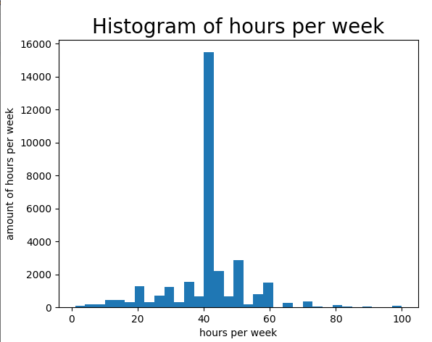

Figure 5 Histogram of hours per week

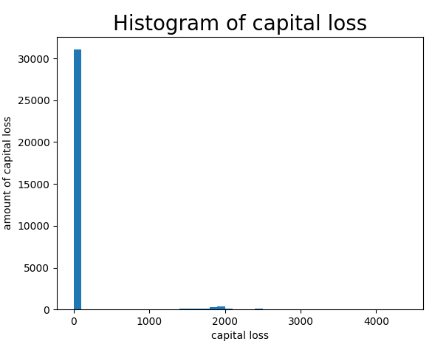

Figure 6 Histogram of capital loss

*2) Calculate the correlation coefficient between income and each of the continuous features.*

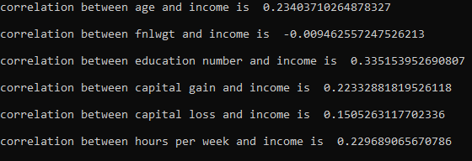

Figure 7 Correlation Coefficient of continuous and income

*3) Calculate the correlation coefficient between income and each value of each discrete feature. Discrete features are workclass, education, marital-status, relationship, and sex. For instance, for workclass, you need to go over the values "Private, Self-emp-not-inc, Self-emp-inc, . . . " and look at the coefficient between income and 0/1 vector obtained by that workclass value as discussed above.*

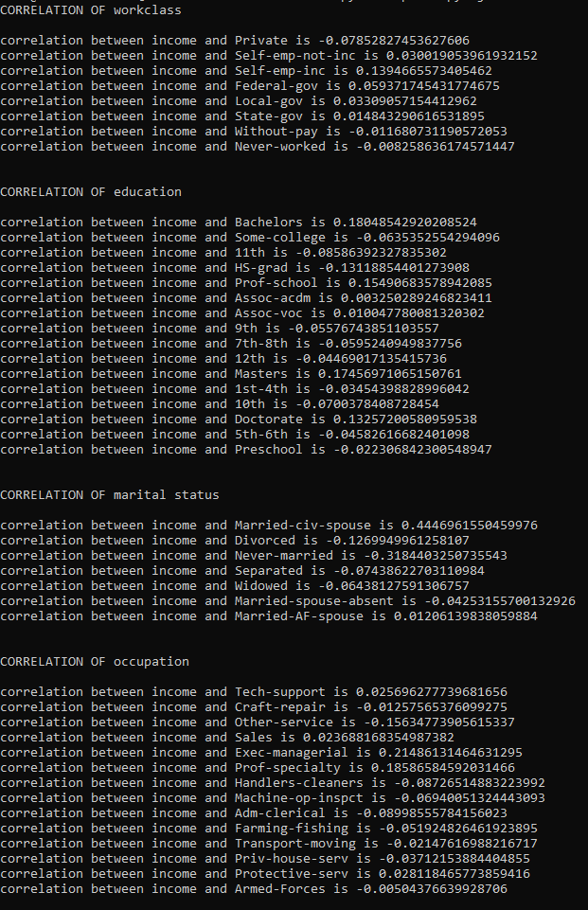

Figure 8 Correlation coefficient of discrete values

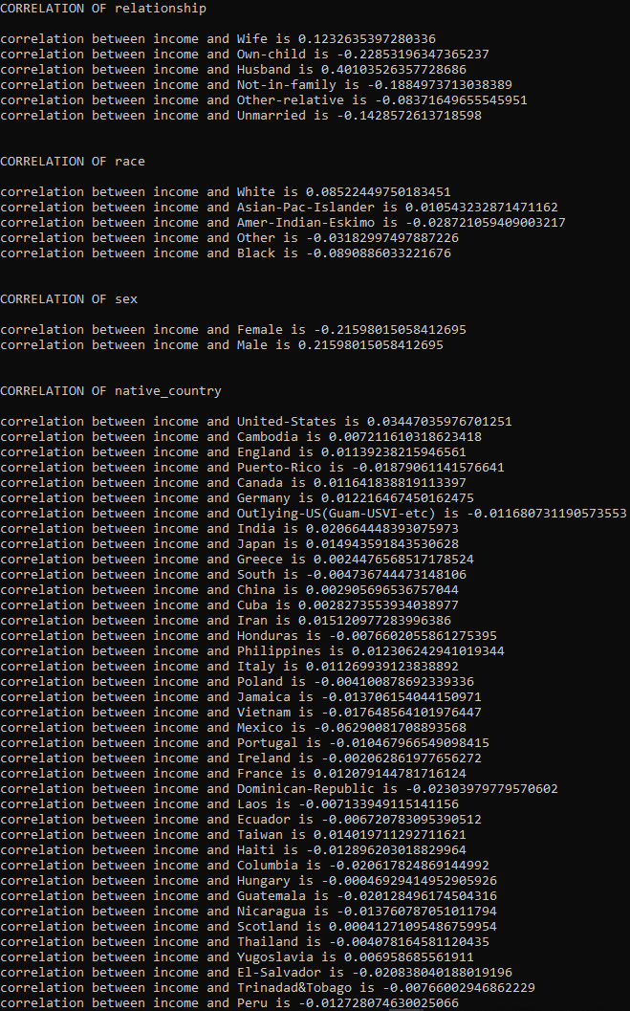

Figure 9 Continued Correlation coefficient of discrete values

*4) For each discrete feature, create a bar plot where x-axis is the feature values (e.g. "Private, Self-emp-not-inc, Self-emp-inc, . . . ") and y-axis is the correlation coefficients obtained in the previous question.*

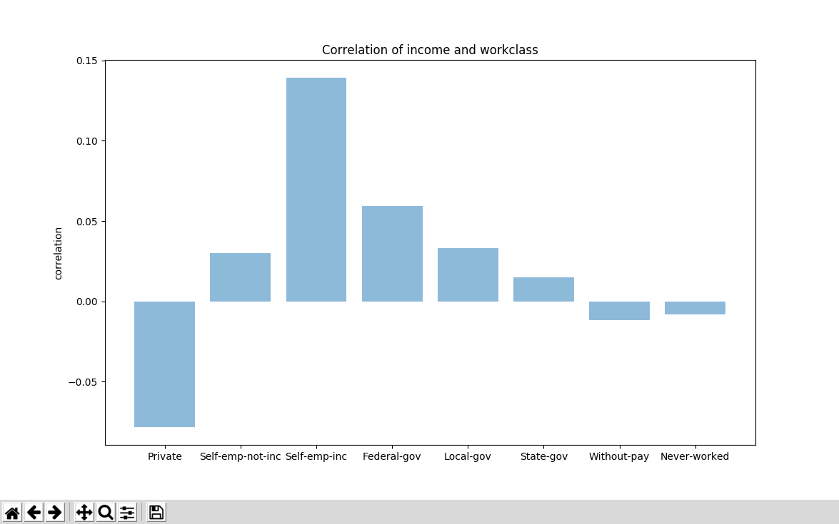

Figure 10 Bar graph of correlation coefficient of workclass divisions

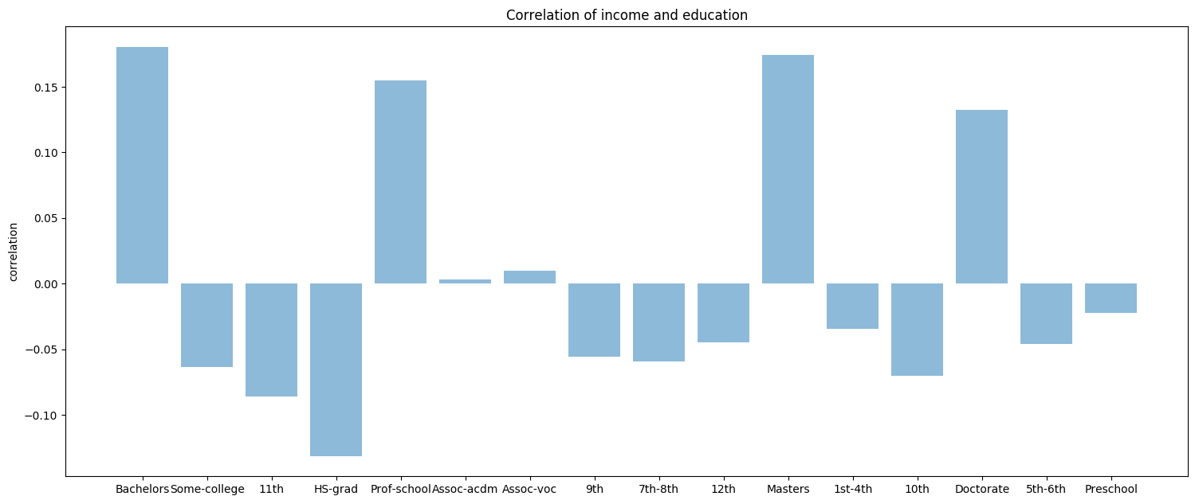

Figure 11 Bar graph of correlation coefficient of education divisions

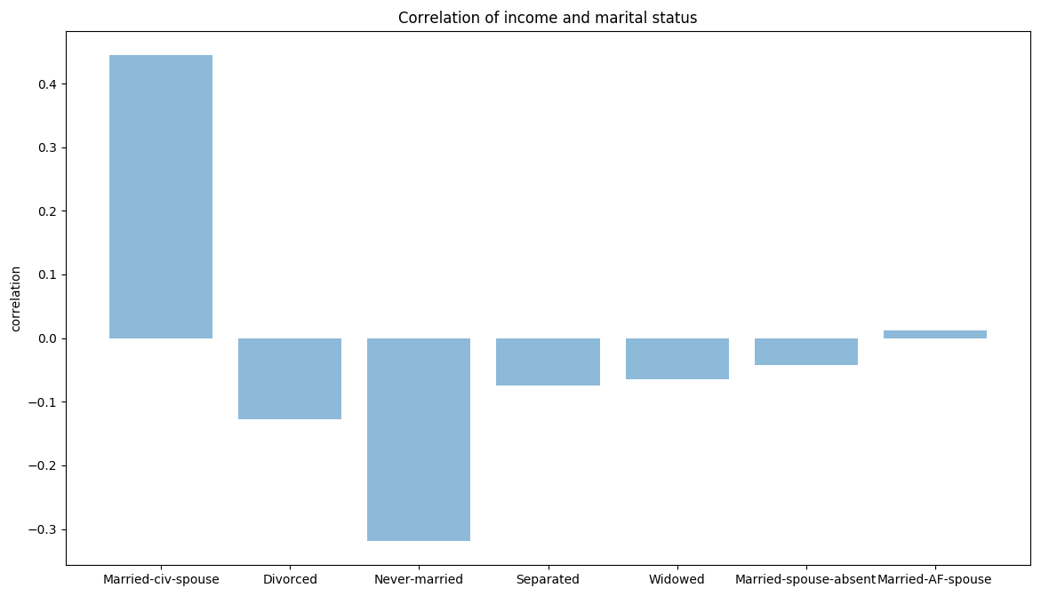

Figure 12 Bar graph of correlation coefficient of marital stauts divisions

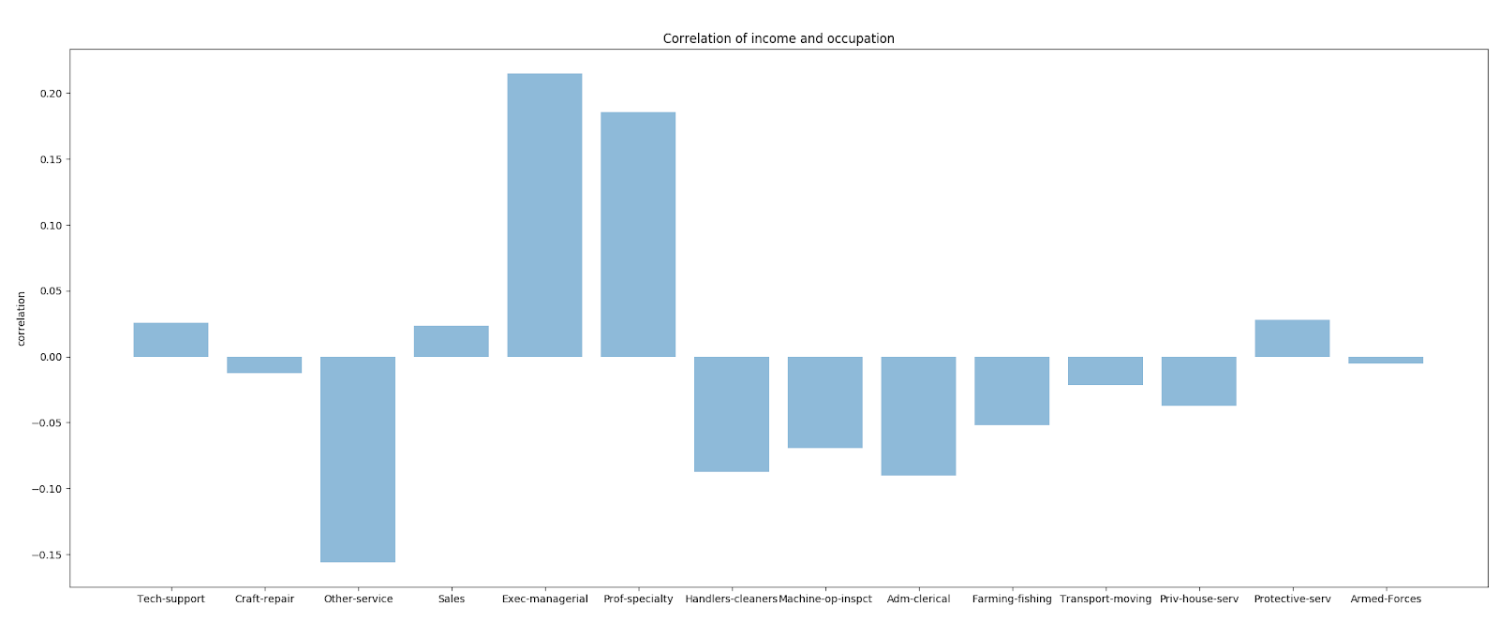

Figure 13 Bar graph of correlation coefficient of occupation divisions

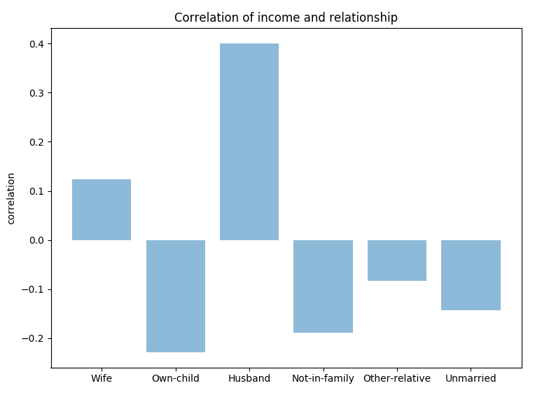

Figure 14 Bar graph of correlation coefficient of relationship divisions

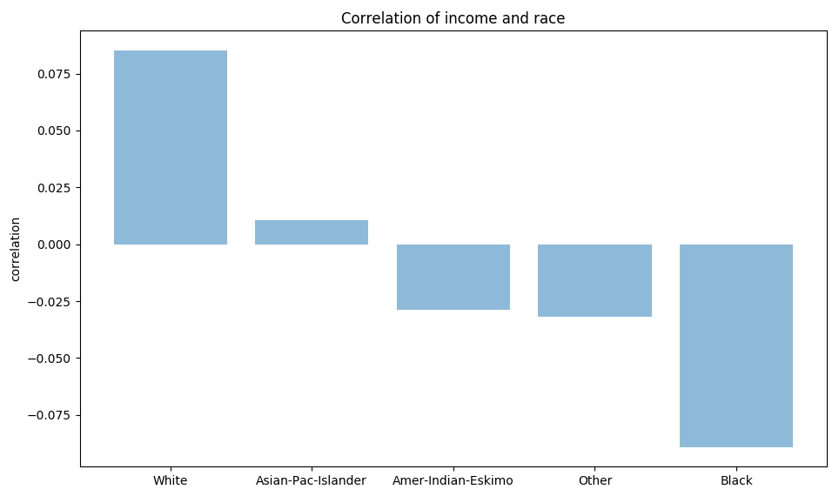

Figure 15 Bar graph of correlation coefficient of race divisions

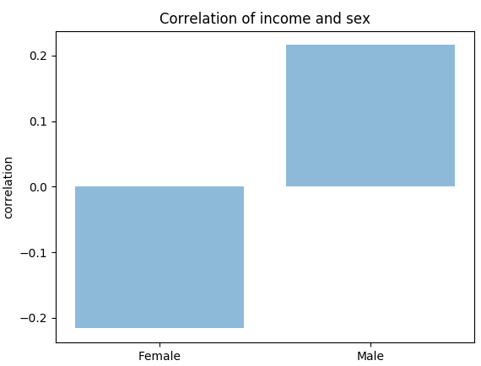

Figure 16 Bar graph of correlation coefficient of sex divisions

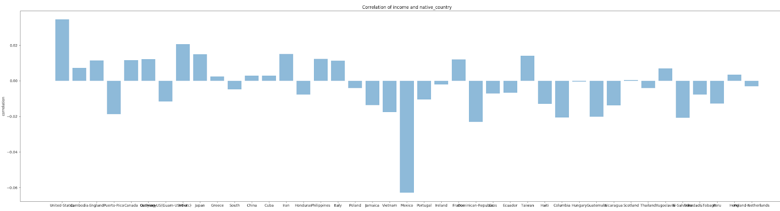

Figure 17 Bar graph of correlation coefficient of native-country divisions

Figure 17 has too many native countries to show properly